- Prolag program for Monkey Banana problem

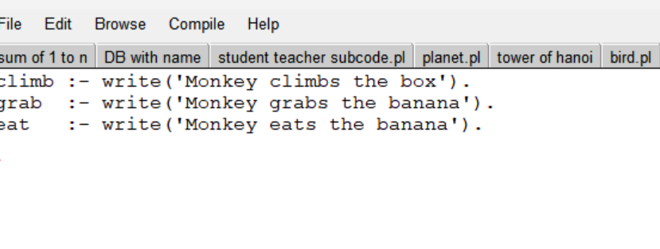
OUTPUT:

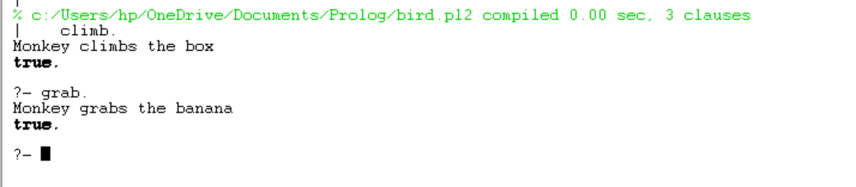

- Prolag program Fruit and its colour using backtracking

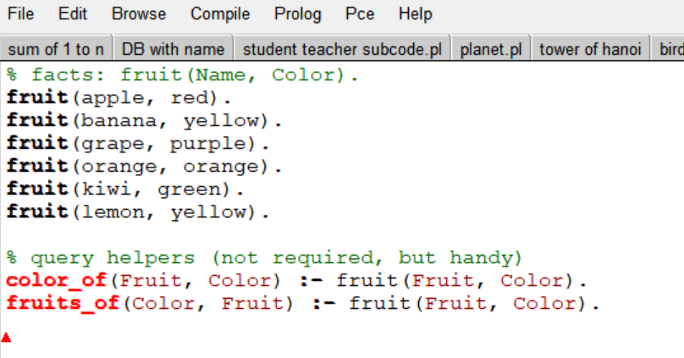

OUTPUT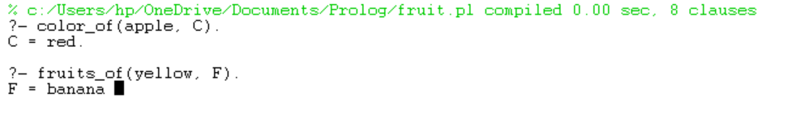
- Implement Best search algorithm

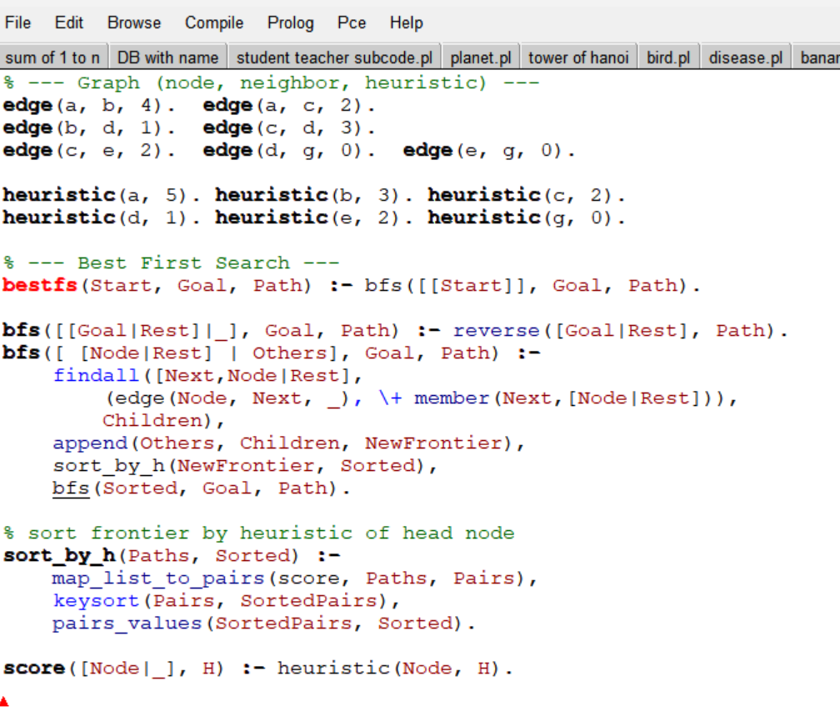

OUTPUT

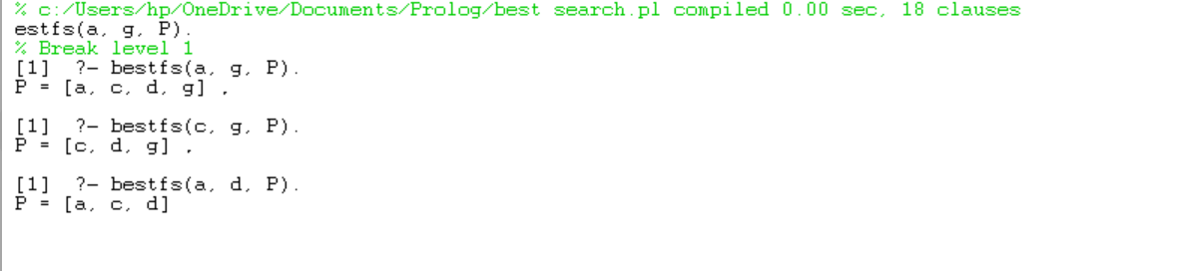

- Prolag program for Medical Diagnose
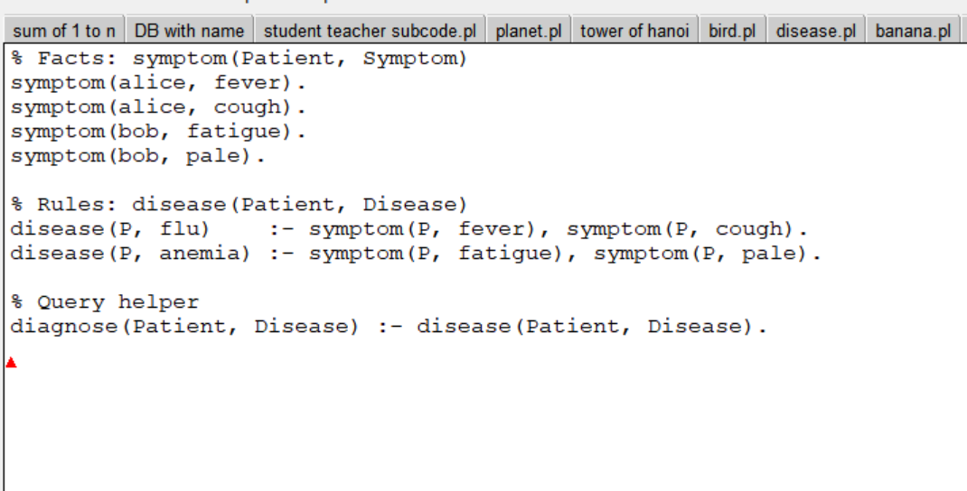

OUTPUT:

